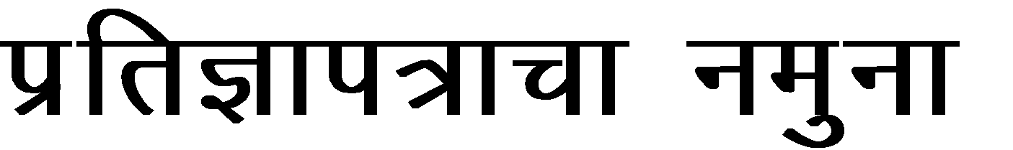
izfr]
ek- fookg uksan.kh vf/kdkjh lkgsc] ukxiwj
izfrKkFkhZ Ø- 1 %& Jh--------------------------------------------------------------------------------------------- o;------------------------------------------------------------------------------------------- jkg.kkj------------------------------------------------------------------------------------ /kank----------------------------------------------------------------------------------------- izfrKkFkhZ Ø- 2%& dq ---------------------------------------------------------------------------------------- o;-------------------------------------------------------------------------------------------- jkg.kkj------------------------------------------------------------------------------------ /kank ----------------------------------------------------------------------------------------
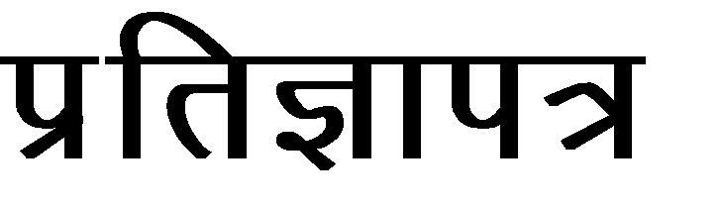
 | vkEgh izfrKkFkhZ ns.ks izek.ks fygwu nsrks fd]
1½ | vkEgh izfrKkFkh egkjk"Vª jkT;kps LFkkfud jghoklh vkgksr- vkEgh ojhy iR;koj
 | jkgr vkgksr-
2½ | eh izfrKkFkhZ Ø- 1 fygqu nsrks dh] ek>s yXu dq- fgP;k cjkscj fn------------@-----------@---------
 | ---------------okj---------------jksth--------------------------------------------------------------------------------------------------------------
 | Lkaiq.kZ iRrk ueqn djkok½ ;sFks laiUu >kys-
3½ | eh izfrKkFkhZ Ø- 1 fygqu nsrks dh] ek>h@ek>s tUe rkjh[k----------@--------@-------------fg
 | vkgs-
4½ | eh izfrKkFkhZ Ø- 1 fygqu nsrks dh] dq- -----------------------------------------------------------------------fgyk
 | iRuh Eg.kwu fLodkj dsysys vkgs- o rhpk tUeHkj lkaHkkG dj.;kph tckcnkjh ek>h
 | Lor% ph jkghy o eh gs yXu Lor%P;k ethZu s dsyys s vkgs- ;koj dksuhgh tksj tcjLrh
 | dsyys h ukgh-
5½ | eh izfrKkFkhZ Ø -2 fygqu nsrs dh] ukes lkS -------------------------------------------------------gs ek>s uko
 | vkgs- ek>h tUe rkjh[k---------@-------@---------gh vkgs o ek>s yXukiqohZps uko dq- --------------
 | ------------- gs gksrs-
6½ | eh izfrKkFkhZ Ø- 2 fygqu nsrks dh] eh gs yXu Jh- --------------------------------------;klkscr dsysys
 | vlwu R;kaP;k cjkscj tUeHkj llakj dj.;kph tckcnkjh ekb&;koj vkgs o eh yXu
 | vkiY;k ethZus dsysys vlwu á yXukckcr dks.khgh tkjs tcjnLrh dsysys ukgh-
7½ | vkEgh izfrKkFkhZ Ø- 1 o 2 fygwu nsrks dh] gs vkEgk nks?kkaps ighys yXu vkgs- rlps
 | ;k yXukiqohZ vkepk ?kVLQksV oxSjs >kysyk ukgh-
8½ | vkEgh izfrKkFkhZ Ø- 1 o 2 fygwu nsrks dh] ;k fookgkph vkEgh brj dksBsgh uksna.kh dysyh ukgh-
9½ | vkEgh izfrKkFkhZ Ø- 1 o 2 fygwu nsrks dh] vkEgh gs yXu vkiY;k ethZuss dsysys vlwu
 | vkEgkyk yXukps jftLVsª’ku izek.ki=kph vko’;drk vkgs-
 | lcc izfrKki= lknj-
LFkG %& ukxiwj 1½------------------------Lok{kjh-------------------------------
fnukad %&----------------@------------@------------------- 2½------------------------Lok{kjh--------------------------
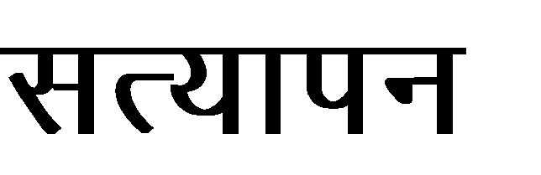
ojhy etdqj ekghrh uqlkj lR; o foÜolfu; vlwu vkt fn------@--------@------------- jksth lgh dsysyh vkgs- rlps gh ekghrh [kksVh vk<GY;kl Hkk-n-fo- dye 199@200 uqlkj f’k{ksl ik= jkghy-
1½-------------------------------------------------------
2½-----------------------------------------------------

